**Impacts of imposed career**

Students face several psychological consequences due to intervention in their career choices. A thorough research of several thesis, analyses and articles has shown that students who were free in making decisions about their career are now most likely to have high level of self-esteem, self-efficacy, and optimism and a low level of pessimism as compared to the students who were forced to opt for a particular career.

Research was made in Jordan University of Science and Technology among the nursing staff and students. 117 randomly selected participants were asked to respond to a questionnaire. Based on the results, it was interpreted that the students were most prominently influenced by three major factors while deciding for their career, namely religious factors, parental pressure, and the only perceived opportunity available. Among these the most depression causing factor was observed to be parental pressure, leaving almost 40.95% of students depressed. While the ratio of depression in the students who chose their career on religious basis was much less [19.1%].

According to a literature published between 1990 and 2018, parents have a great influence on every decision that their children make. Parents can either let their kids explore their potential and abilities, or they can carve a particular path for them and make them stick to it. Studies reveal that children need the support of their parents while making big decisions like those about career. A lack of such support can lead to frustration and stress in children, and they end up going for a career selected by their parents. Research was made in Odisha in which 160 students, from different fields, were randomly selected and were asked to respond to a questionnaire. The questionnaire was personally administered to the respondents by the researcher and the results were compared through the chi-square analyses. The results showed that several academic and personality traits of students with imposed career, are damaged. Among such traits, the prominent ones are:

**1.1. Academic efficiency:** It is a commonly observed fact that when someone does something willingly, he will do it with all his heart and hence will accomplish more, as compared to a situation when someone is compelled to do something. According to the results of the study, in case of self-choice the level of academic efficiency was much higher as compared to the situation when career was imposed by parents. However, when career was chosen by mutual consent of both parents and students, it produced somewhat more satisfactory results.

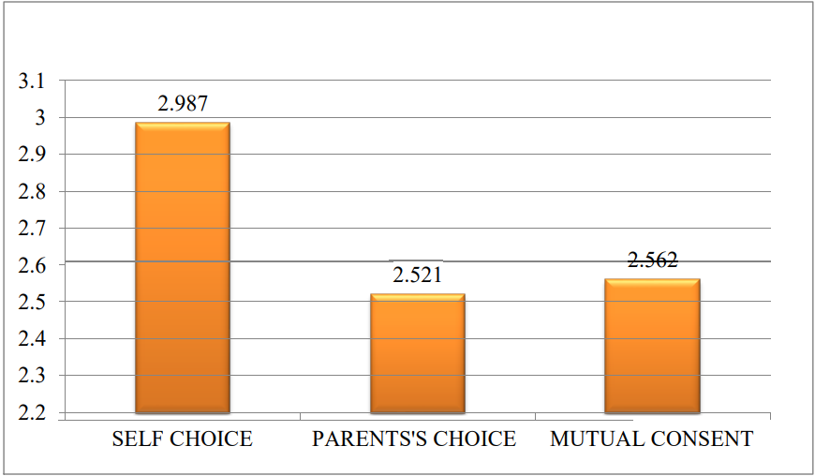

(Graph taken from a thesis on Academic and Psychological Consequences of Imposed Career Choices by the student at National Institute of Technology, Rourkela  [http://ethesis.nitrkl.ac.in/6733/](%20http:/ethesis.nitrkl.ac.in/6733/)

Published on May 2015)

**1.2. Confidence:** When a student chooses his career himself, then he would follow it willingly and will have complete confidence in himself, which will be reflected in his personality and academic performance. On the other hand, in case of imposed career a student performs unwillingly and achieves less. This causes him to lose confidence in his abilities. The graph shows that the level of confidence increases considerably in the students who were decisive in their career choice as compared to those who were indecisive at the time of making their career choice.

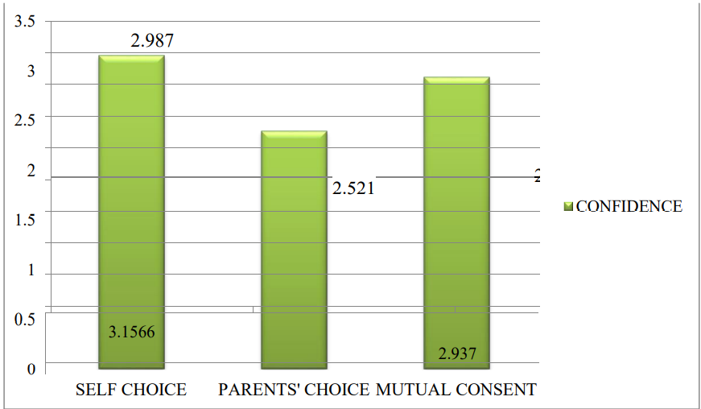

(Graph taken from a thesis on Academic and Psychological Consequences of Imposed Career Choices by the student of National Institute of Technology, Rourkela  [http://ethesis.nitrkl.ac.in/6733/](%20http:/ethesis.nitrkl.ac.in/6733/)

Published on May 2015)

**1.3. Self-esteem:** Experts believe that people with low self-esteem are less likely to get promoted, are generally less smart and suffer from depression. Forcing children to opt for something that is quite opposite to their interests, effects their self-esteem. Students with low self-esteem often face a lot of challenges to fit in the world. The t-test reveals a significant difference of 2.62 between the level of self-esteem in the cases of self-choice and parent’s choice.

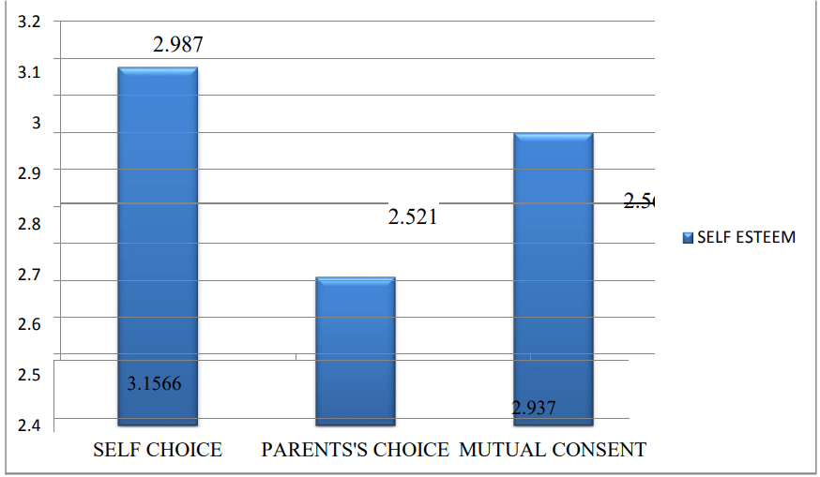

(Graph taken from a thesis on Academic and Psychological Consequences of Imposed Career Choices by the student of National Institute of Technology, Rourkela  [http://ethesis.nitrkl.ac.in/6733/](%20http:/ethesis.nitrkl.ac.in/6733/)

Published on May 2015)

**1.4. Frustration and depression:** Frustration and depression are negative emotions of humans and lead to self-destructing habits and attitude in the students. These factors also cause several health problems including insomnia and decreased appetite, along with the less satisfaction level. The students with imposed career suffer heavily from depression as per survey. According to that survey, the depression level is significantly 2.42% higher.

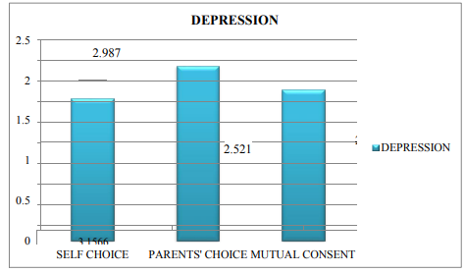

(Graph taken from a thesis on Academic and Psychological Consequences of Imposed Career Choices by the student of National Institute of Technology, Rourkela  [http://ethesis.nitrkl.ac.in/6733/](%20http:/ethesis.nitrkl.ac.in/6733/)

Published on May 2015)

1. **Career Counseling; a solution**

All the above-mentioned problems not only affect the students on individual level, but they also disrupt the peace of the whole society, and hence they call for a timely and reasonable solution. One of the most rational and sensible solution, that has also been tested various times, is the introduction of career counseling and career courses in schools and colleges.

While deciding for a career, students must have certain information, like knowledge about themselves, the world of professions, certain hurdles that may occur in their path, variety of career options available and the demand of occupations. Normally students overlook such important factors while deciding for a career and hence end up choosing a wrong path for the rest of their lives. Hence there is a need of career professionals and researchers who have certain techniques to aid students in acquiring this information.

**2.1. Career Counseling and Career Courses:**

Career counselling is a process that focuses on assisting individuals in better understanding themselves as well as current workplace trends so that they can make better decisions about their careers and education. Career counselling can help with a variety of issues ranging from poor time management to family trust issues to disagreements between parents and children about which career to pursue. Similarly, career courses are the courses that are taken up at a college, before entering a university. These courses are aimed at facilitating students in decision making and career planning skills. They have been found to produce several positive outcomes

**2.2. Impacts of Career Counseling and Career Courses on Students:**

A study was conducted by three professors at Florida state university. The aim of this study was to answer the question:

" Does a career course positively impact student's career decision state (career certainty, satisfaction), and career affective state (level of goal instability, negative career thinking)?[1]

For conducting this study 108 students, enrolled in five different undergraduate career courses, in a large public university were randomly selected. They included 66 males and 42 females, with an average age of 20.

The participants were evaluated using two measures, the OAQ (Occupational Alternatives Questionnaire) and Satisfaction with Choice Question.

The OAQ comprises of two basic questions: 1." List of all occupations you are considering right now" and 2."Which occupation is your first choice?"[2] If the answer to second question hasn't been decided, then the participants are supposed to write undecided. The OAQ is analysed using a scale from 1-4, where higher scores indicate that individuals are more certain about their career choice.

The satisfaction with choice question includes a single question: " How well are you satisfied with your first choice?"[3] It is also analysed on a scale from 1-6 and higher scores indicate that students are more dissatisfied with their career choice.

Prior to conducting the study, it was approved by the university's administration and the participants were informed about it. Those who agreed to become part of the study were given a consent form and a questionnaire, which compromised the OAQ and Satisfaction with choice question.

The data obtained was analysed and compared using several tests and the results showed that career courses significantly benefitted the students in making decisions about their careers.

Another similar study was made in the University of Montana (by Sidra Tabassum Baig Master of Arts, Counsellor Education, The University of Montana, Missoula, MT, 2008) and based on the results of this study it was recommended that career counselling and career courses needed to be made mandatory for undergraduates.

Based on the above-mentioned studies it is evident that career counseling and career courses help students better understand themselves, their own interests, and the career options available for them, hence making career decision easier. Therefore, it would not be wrong to say that an introduction of career courses in schools and colleges can help lift the burden of frustrated and depressed students and employees from society.

1. **Recommendations**

To properly introduce career counselling in schools and colleges, special career courses need to be designed. These courses should be designed, keeping the following things in mind:

1. These courses should be introduced at college and school levels before the students enter university for a specific professional field.
2. The career courses should be no more than of two credit hours, so that the students won’t feel overburdened.
3. The courses should be designed such that, they enable the kids to explore their own interest and abilities.
4. Once the students discover their interests, they should be informed with all the career options that align with their interests.
5. In case on intervention by parents, the career professionals, should arrange sessions with parents and enlighten them about the negative consequences of imposed career.
6. The main motive of these courses should be to enable students to make decisions about their career, without any mental pressure.
7. **Conclusion**

In a nutshell we can say that career counselling and career courses can help save a lot of students from choosing such a career that does not align perfectly with their interests and abilities, and hence it can save them from frustration and depression. A stage when student must decide for a particular career to pursue is a very critical one, and it needs to be tackled by professionals only. It might not seem that serious but even a tiny misinterpretation while making this decision can not only destroy the life of an individual, but it also disturbs the order and harmony of the society. It has adverse effects on the personality of the individual and causes them to lose confidence and self-esteem. Therefore, it is the need of the hour to make career courses compulsory for college students.

1. Career Course Impact on College Students’

   Career Decision and Affective States

   Vanessa F. Freeman, Janet G. Lenz, and Robert C. Reardon
2. (Slaney, 1980)
3. (Zener & Schnuelle, 1972; modified by Holland et al., 1975)